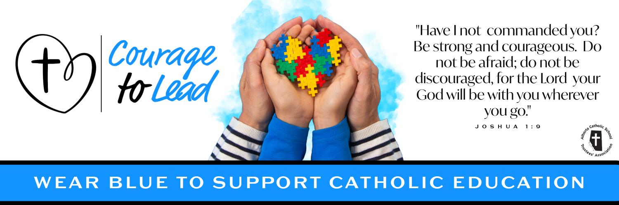
Catholic Education Week 2024
Liturgy of the Word
Monday, May 6, 2024

Introduction
During Catholic Education Week, we give thanks for the invaluable gift of Catholic Education. This year the theme of Catholic Education week is “Courage to Lead”.

“Have I not commanded you? Be strong and courageous. Do not be afraid; do not be discouraged, for the Lord your God will be with you wherever you go.” – Joshua 1:9

Each day this week we’ll take time to celebrate and pray for all members in our Catholic Education community.

This week we give thanks to God for the gift of our parents and for their courageous yes to entrusting their children to the care of our schools.

Please join us in the singing of our opening hymn: Blest be the Lord

Verse 1, Blest be the Lord (until 1:26) - https://www.youtube.com/watch?v=gz0Yzc7DNzE

Opening Prayer
Heavenly Father, we thank you for the precious gift of Catholic Education.

As we celebrate Catholic Education Week, give us the grace to carry out our daily tasks with a positive attitude and an eagerness to learn more about you.

Help us to walk confidently in your footsteps so we can courageously lead others to your loving heart.

We ask this in the name of the Father, and of the Son and of the Holy Spirit. Amen

Gospel Reading

The Lord be with you.
R. And with your Spirit.

A reading from the holy gospel according to John.
R. Glory to you, Lord

Jesus said to the Pharisees, “I am the good shepherd. The good shepherd lays down his life for the sheep. The hired hand, who is not the shepherd and does not own the sheep, sees the wolf coming and leaves the sheep and runs away— and the wolf snatches them and scatters them. The hired hand runs away because a hired hand does not care for the sheep.“ I am the good shepherd. I know my own and my own know me, just as the Father knows me and I know the Father. And I lay down my life for the sheep. I have other sheep that do not belong to this fold. I must bring them also, and they will listen to my voice. So there will be one flock, one shepherd.” [John 10. 11-16]

The gospel of the Lord.
R. Praise to you, Lord Jesus Christ.

Prayers of the Faithful
Response is: Lord, hear our prayer.
R. Lord, hear our prayer.

For all leaders in Catholic Education that through the guidance of the holy spirit they may grow closer to God in all that they do, we pray to the lord.

For the pope, that the risen lord may grant him good health and strength as he continues to lead the church with courage, we pray to the lord.

For Catholic Education: That during our celebrations of Catholic education Week, we may live out the mission of “Courage to Lead” with conviction, we pray to the Lord

For all those who are sick in our communities and all those who suffer that they may find help and consolation, we pray to the Lord.

For all our personal intentions. *pause* we pray to the lord.

Closing Prayer
Lord, thank you for the blessings of our parents.

Their dedication to Catholic Education and their commitment to maintaining life in the home, which compliments the faith life of the school, is remarkable.

Help us to support our parents in the valuable work they are doing and to celebrate with them the successes that we share in our Catholic schools.

We ask this in the name of the Father, and of the Son and of the Holy Spirit. Amen.

Recessional Hymn:

Verse 2, Blest be the Lord (starts at 1:26) - https://www.youtube.com/watch?v=gz0Yzc7DNzE

