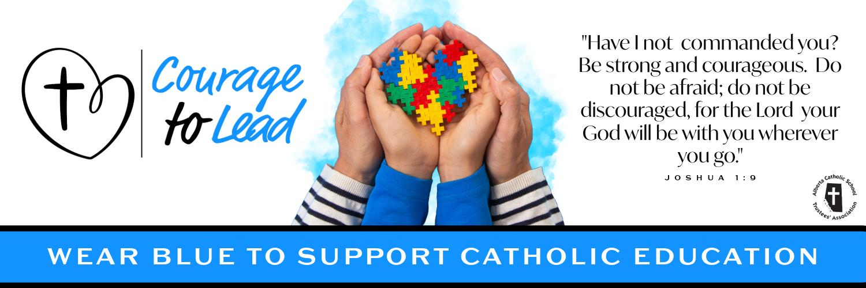
Catholic Education Week 2024
Liturgy of the Word
Wednesday, May 8, 2024

Introduction
Today, as we continue our celebration of Catholic Education, we give thanks for the gift of Teachers and staff.

We are blessed to have dedicated, talented and courageous teachers and staff that guide the heart and mission of Catholic Education.

We also reflect upon the coming of Holy Spirit in the Gospel reading today. Let us renew our commitment to be ‘light of the world and salt of the earth’ so that all may come to know the love and mercy of our saviour, Jesus Christ.

Please join us in the singing of our opening hymn: Christ Be Our Light

Suggestions:
Verse 1 & 2 (until 1:37), Christ, be our light - https://www.youtube.com/watch?v=KMkfKXLcm5Q&list=RDEMN1f6BMaSJZnt2Tnztg3Hyw&index=17

Opening Prayer
Heavenly Father, we thank you for the precious gift of Catholic Education.

As we celebrate Catholic Education Week, give us the grace to carry out our daily tasks with a positive attitude and an eagerness to learn more about you.

Help us to walk confidently in your footsteps so we can courageously lead others to your loving heart.

We ask this in the name of the Father, and of the Son and of the Holy Spirit. Amen

Gospel Reading
The Lord be with you.
R. And with your Spirit.

A reading from the holy gospel according to John.
R. Glory to you, Lord

When Jesus knew that his hour had come to depart from this world and go to the Father, he said to the disciples: “I still have many things to say to you, but you cannot bear them now. When the Spirit of truth comes, he will guide you into all the truth; for he will not speak on his own, but will speak whatever he hears, and he will declare to you the things that are to come. He will glorify me, because he will take what is mine and declare it to you. “All that the Father has is mine. For this reason I said that he will take what is mine and declare it to you.”
[John 16. 12-15]

The gospel of the Lord.
R. Praise to you, Lord Jesus Christ.

Prayers of the Faithful
Response is: Lord, hear our prayer.
R. Lord, hear our prayer.

For all leaders in Catholic Education that through the guidance of the holy spirit they may grow closer to God in all that they do, we pray to the lord.

For the pope, that the risen lord may grant him good health and strength as he continues to lead the church with courage, we pray to the lord.

For Catholic Education: That during our celebrations of Catholic education Week, we may live out the mission of “Courage to Lead” with conviction, we pray to the Lord

For all those who are sick in our communities and all those who suffer that they may find help and consolation, we pray to the Lord.

For all our personal intentions. *pause* we pray to the lord.

Closing Prayer
Dear God, our schools are blessed with the talented work of our teachers and staff.

Continue to guide the important work of our valued teachers as they work with our students.

Continue to lead our staff and administrators as they work to provide faith-filled direction for our school communities.

Lord, be with us in our school communities as we continue to work with you in faith.

We ask this in the name of the Father, and of the Son, and of the Holy Spirit. Amen.

Recessional Hymn

Verse 3 (starts at 1:37), Christ be our Light - https://www.youtube.com/watch?v=KMkfKXLcm5Q

